Glacier Slime Activity
Synopsis: Students will develop a model demonstrating the properties of glaciers and how it affects the landscape.
Standards: MS-ESS2-2
Time: 45 minutes-1 hour
Supplies:
Glacier slime
-a large bowl
-1 teaspoon of baking soda
-1 cup of water
-1 cup of clear glue
-1/4 cup of contact lens solution
-Stirring implements
-Baking pan such as a 9’’by 13’’
Erratics
-can be beads, small rocks, shells, and other small, lightweight objects
Information background: Glaciers are large accumulations of ice that move through its own weight and gravity. Although glaciers seem still, over many years they slowly move. As glaciers progress, they churn, pluck, and erode the landscape; carrying debris with them. When glaciers melt, their material is left behind. Boulders that survive these transports are called “erratics.” Erratics can mark the body and frontline of a glacier’s body. Geologists use erratics to determine the shape of an ancient glacier.
Glaciers and slime both move in a non-Newtonian fashion, neither liquid or solid. However, whereas slime can move in minutes, a glacier can take years. We will demonstrate this behavior in today’s activity and how glaciers can change the landscape.
Instructions:
- Using a dry erase marker, measure and mark dots on the tray that are equal distance from each other.
- Place the objects on the dots. Each row should be a different color or feature. This will help you keep track of the objects as they are affected by the glacier slime. It can look something like the image below.
  - 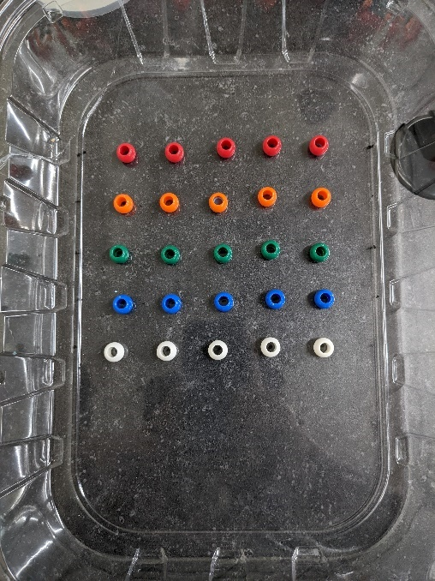
- Carefully prop one side of the tray up about half an inch or so. Ensure the objects remain on their marked locations.
- Pour 1 cup of glue into a large bowl.
- In a separate container, add 1 teaspoon of baking soda into 1 cup of warm water. Stir until baking soda has dissolved.
- Pour the baking soda mixture into the glue bowl and mix until combined.
- Pour ¼ cup of contact lens solution into the glue/baking soda bowl and quickly mix together until the slime pulls away from the bowl wall. You may have to use your hands to thoroughly mix the ingredients.
- Pour the slime onto the raised side of the tray. You may have to pour intermittently to allow the slime time to spread out. Observe the progression of the slime over ten minutes. It should look similar to the image below.
  - 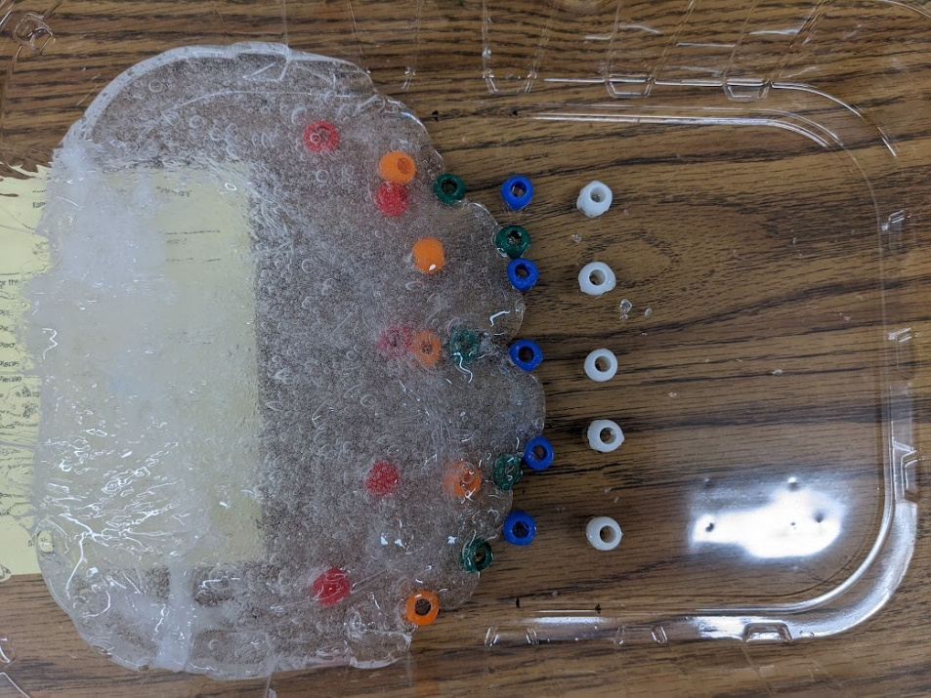
  - Question 1: Describe the shape of the slime as it moves.
  - Question 2: How does the slime affect your erratics? Are all the erratics affected equally by the slime?
  - Question 3: Imagine if the slime disappeared (or melted like a glacier) and left behind the erratics. How well do the erratics represent the size and shape of the glacial slime? How would that affect our understanding of where glaciers existed in the real world?
- Remove the slime from the tray and return it to the bowl. Repeat the experiment but this time change a variable. You can increase the height of the tray and measure how fast the slime moves, change the location of the erratics, or change the material of the erratics. Or something else! Repeat step 8.
  - Question 4: What variable did you change for your second experiment? How did this change the outcome of the experiment?

