Counties of Kansas
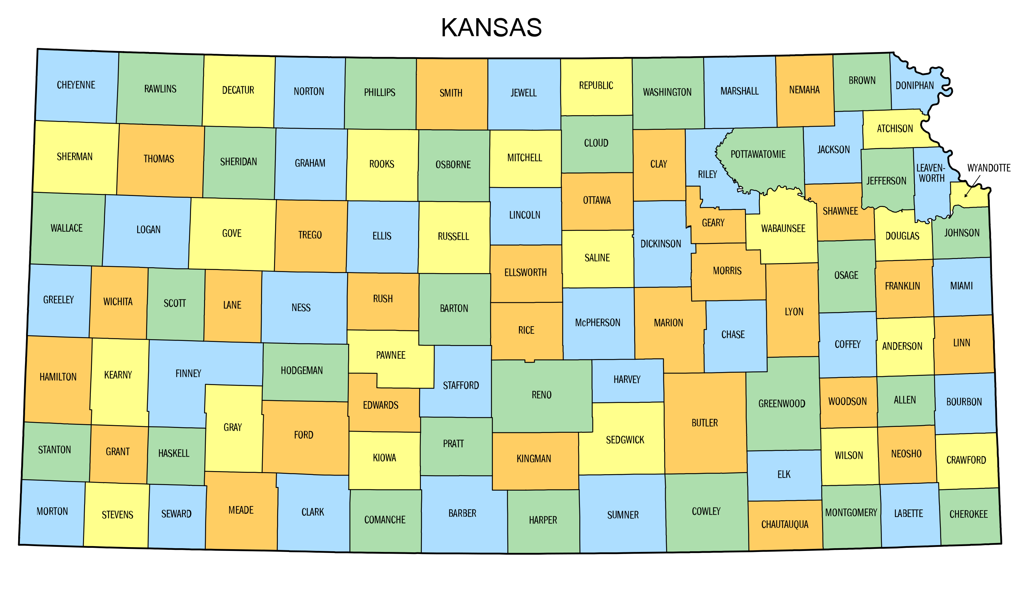

Proportion of Water Usage in Kansas Map
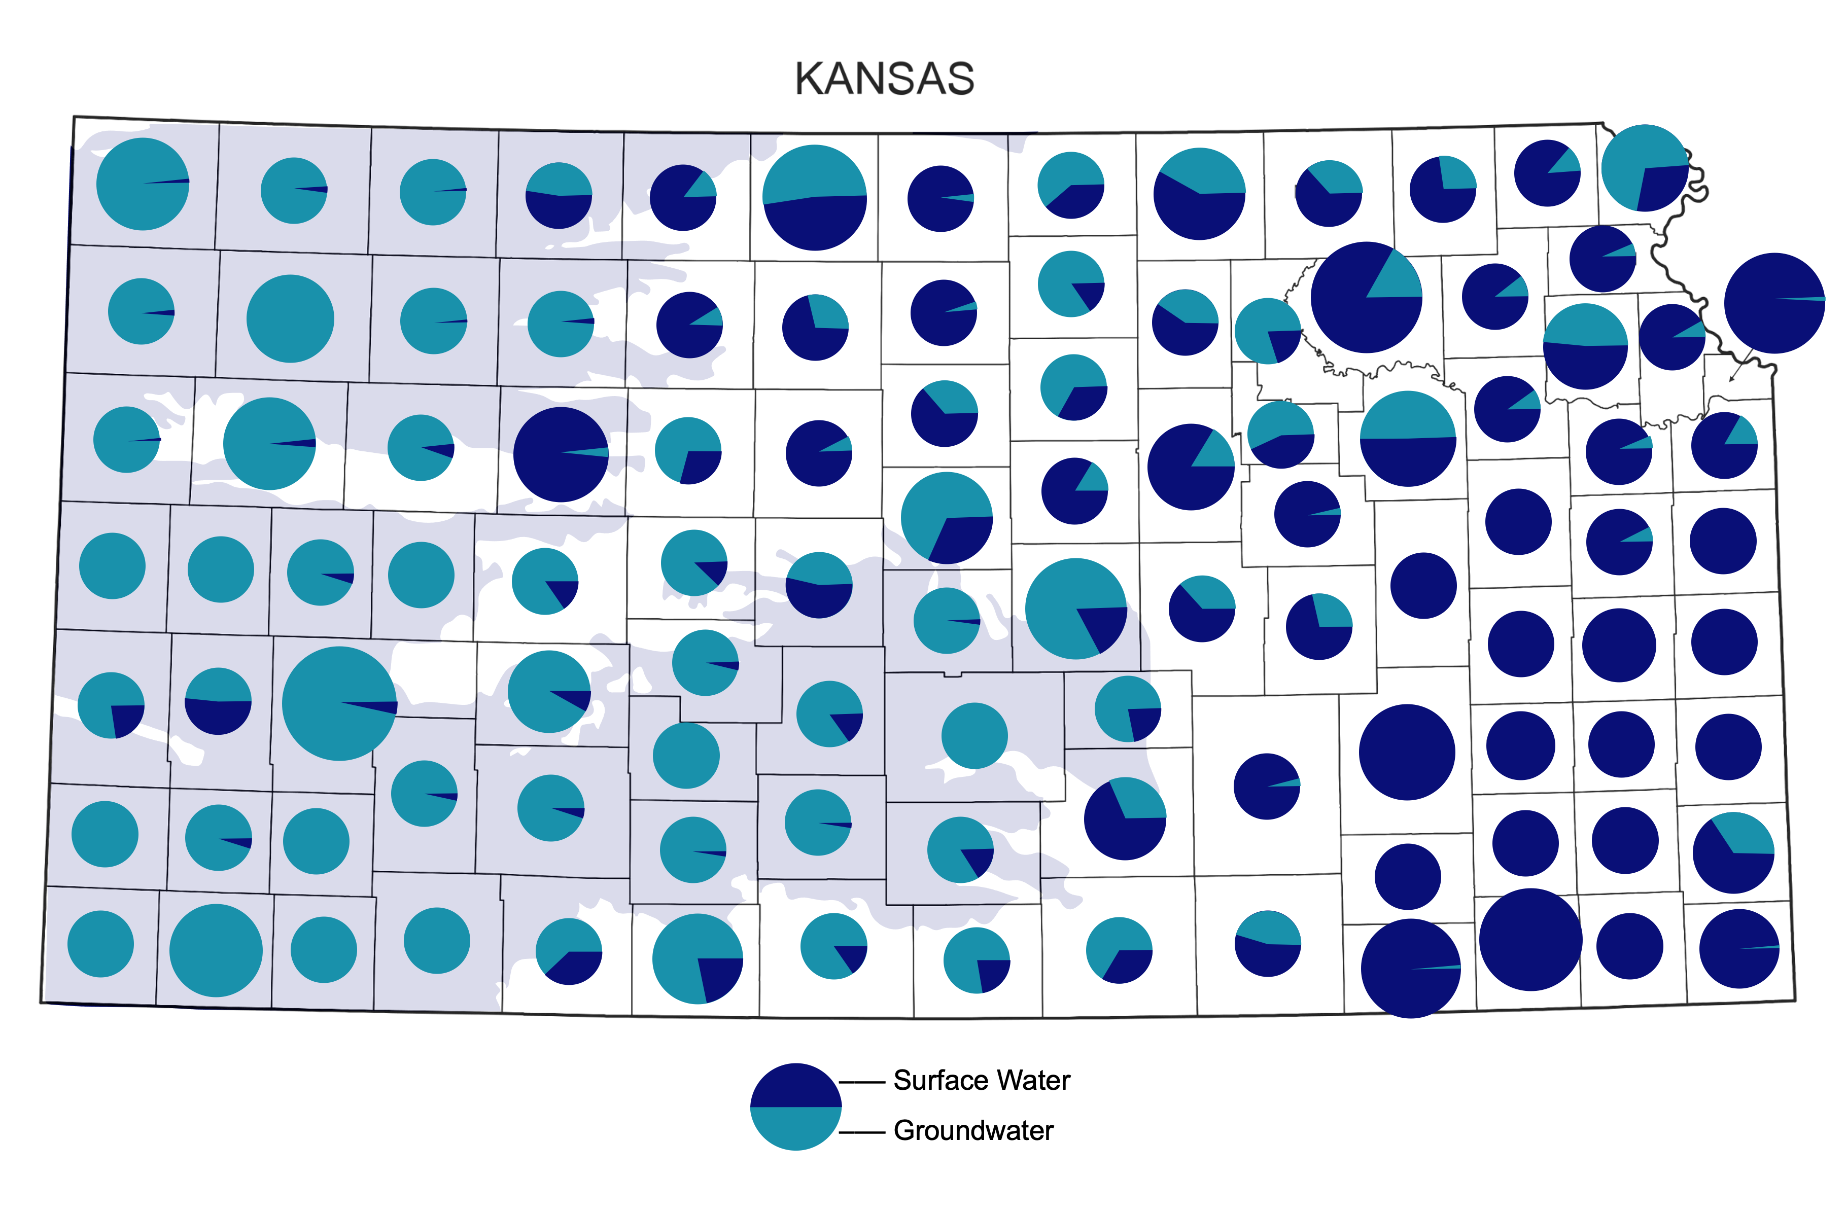
This map shows the proportion of water usage in every county of Kansas. A higher amount of dark blue means a county’s water source comes from surface water like rivers, lakes, and reservoirs. A higher amount of light blue means a county’s water source comes from groundwater. The shaded grey area indicates the High Plains Aquifer region.

Annual Precipitation Map of Kansas
