Tracking Human Impact on the High Plains Aquifer
Background Information: Aquifers are an important source of water from underground and are used by communities across Kansas. However, this is a limited resource and a high amount of research goes into studying these aquifers and how much water is left. Geohydrologists use wells to measure the current water level of aquifers. By yearly measuring these wells, scientists can understand how water levels fluctuate and by extension document the current health of the overall aquifer.
Goal: For this activity, you will observe well data and maps produced by the Kansas Geological Survey and understand how pumping wells impact the High Plains Aquifer.
How to read well data: You will be reading data from wells spread throughout western Kansas. The following well example will guide you through terminology and numbers.
Example is from http://geohydro.kgs.ku.edu/geohydro/wizard/wizardwelldetail.cfm?usgs_id=382539100541601

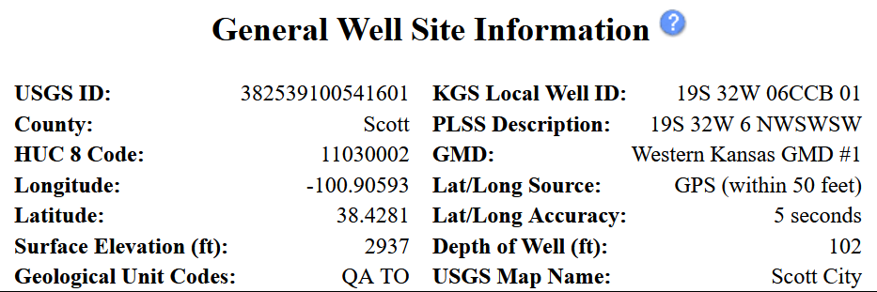
NOTABLE TERMS
KGS Local Well ID: the designated ID for the well. KGS measures over 1,400 wells every year and use this identification system to keep track of them.
Surface Elevation (ft): height above sea level for the well
GMD: short for Groundwater Managing District. These are districts where communities work together to set goals and standards for proper water management. There are five GMD districts in Kansas, all of which are located above the High Plains Aquifer.
Depth of Well (ft): The total length of the water column underground. This is how deep the water goes before it hits bedrock.
In this case, the well ID is 19S 32W 06CCB 01. It’s located in Scott County, at coordinates -100.905 longitude and 38.428 latitude, within Groundwater Managing District #1. The well is located 2,937 feet above sea level, and the total length of the well depth is 102 feet.

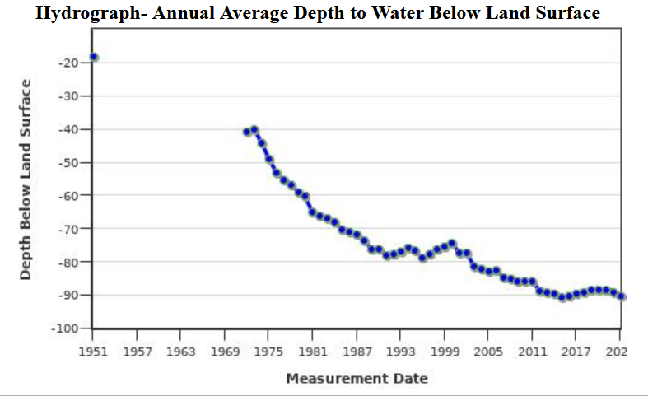
Graph and Data Analysis
The graph shows how water level depth has changed in the well since data collection began. The X-Axis shows the years. The Y-Axis shows the water level depth at the time of observation.
Please note that “water level depth” shows the number of feet below the surface before you hit water. The depth of well is the number of feet before you hit bedrock (and thus no more water). Depth of well will always be greater than water level depth.
We can acquire robust data when we look at the table below the graph. The two important columns you will use are “Date” and “Depth to Water.” The first observation was on April 1st, 1951, with a water level depth of -18 feet below the surface. The most recent measurement was on May 16th, 2023. The water level depth is listed as -90.16 feet below the surface. That means the water level has dropped 72.16 feet since it was first measured.
Now we can compare the final measurement of the water level to the total measurement of the well. Based on what we saw above, the total depth of the well is 102 feet. 102 minus 90.16 means we have 11.84 feet of water left in the water column.

Part 1: First, click on this link, it will take you to the High Plains Aquifer Interactive Atlas. This is a collection of wells the Kansas Geological Survey studies to better understand the High Plains Aquifer. Write down relevant information and be sure to save the links on this document.
Click on one of the green dots on the High Plains Aquifer Interactive Atlas. A little box will pop up next to your mouse; click on “More info” next to “WEBSITE” which will pop open a new tab with in-depth information on the well, its depth, and its current water level. Answer the following prompts for three different wells of your choice.
Well 1
Copy and paste the well link:
Well ID:
County:
Latitude and Longitude:
GMD:
Depth of the Well:
Date of First Measurement:
Water Level Depth of First Measurement:
Date of Latest Measurement:
Water Level Depth of Latest Measurement:
Change in feet between the first and latest measurement:
Amount of water level in feet left in the water column:

Well 2
Copy and paste the well link:
Well ID:
County:
Latitude and Longitude:
GMD:
Depth of the Well:
Date of First Measurement:
Water Level Depth of First Measurement:
Date of Latest Measurement:
Water Level Depth of Latest Measurement:
Change in feet between the first and latest measurement:
Amount of water level in feet left in the water column:

Well 3
Copy and paste the well link:
Well ID:
County:
Latitude and Longitude:
GMD:
Depth of the Well:
Date of First Measurement:
Water Level Depth of First Measurement:
Date of Latest Measurement:
Water Level Depth of Latest Measurement:
Change in feet between the first and latest measurement:
Amount of water level in feet left in the water column:

Well Review:
Of the three wells, which had the deepest well depth? Which had the shallowest?:
Which well had the greatest change since the first measurement?
Which well has the least amount of water left in its column?
Why do you think there may be differences among the wells?

Part 2: We’re now going to read four maps made by the Kansas Geological Survey. These maps pull together all the wells from across the state to help us better interpret the High Plains Aquifer and our potential impact on them.
Let’s look at the first map below. This shows the estimated saturated thickness of the aquifer before it was developed.
What colors designate the shallowest regions?:
What colors designate the deepest regions?:
What region of the state stores the largest amount of water?:
Review your three wells and compare it to the map’s legend. Based on “Depth of Well,” what would be the color for
Well 1? Well 2? Well 3?
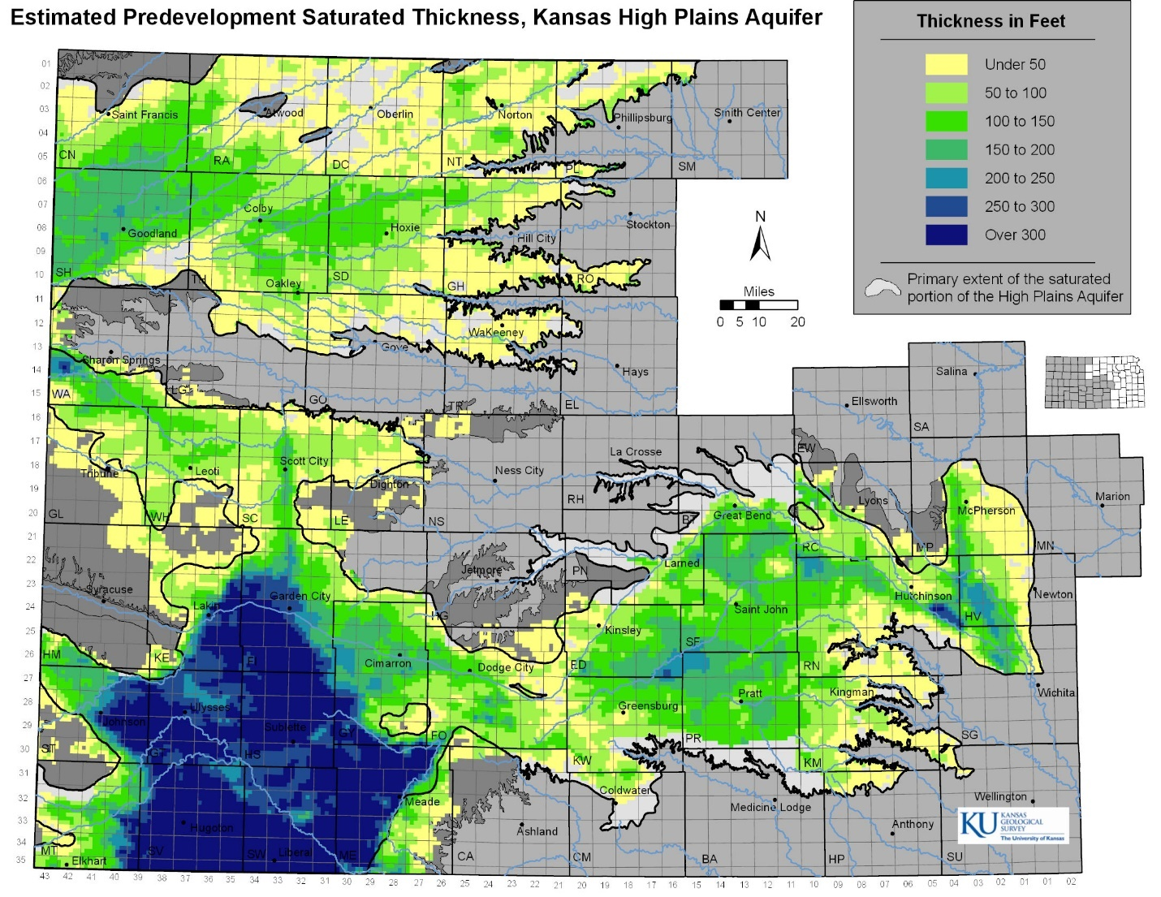

Now let’s look at how much the water level has changed since predevelopment to today. This map uses the first and last measurement differences to designate the different colors in the region.
What color indicate an increase in thickness?
What colors indicate the biggest decreases in thickness?
Where are the biggest decreases located in Kansas?
How do these big differences relate to the Predevelopment depth as seen in the first map?
Where are the increases primarily found in Kansas? What do you think may account for those increases?
What color/symbol would you designate for your wells?
Well 1? Well 2? Well 3?
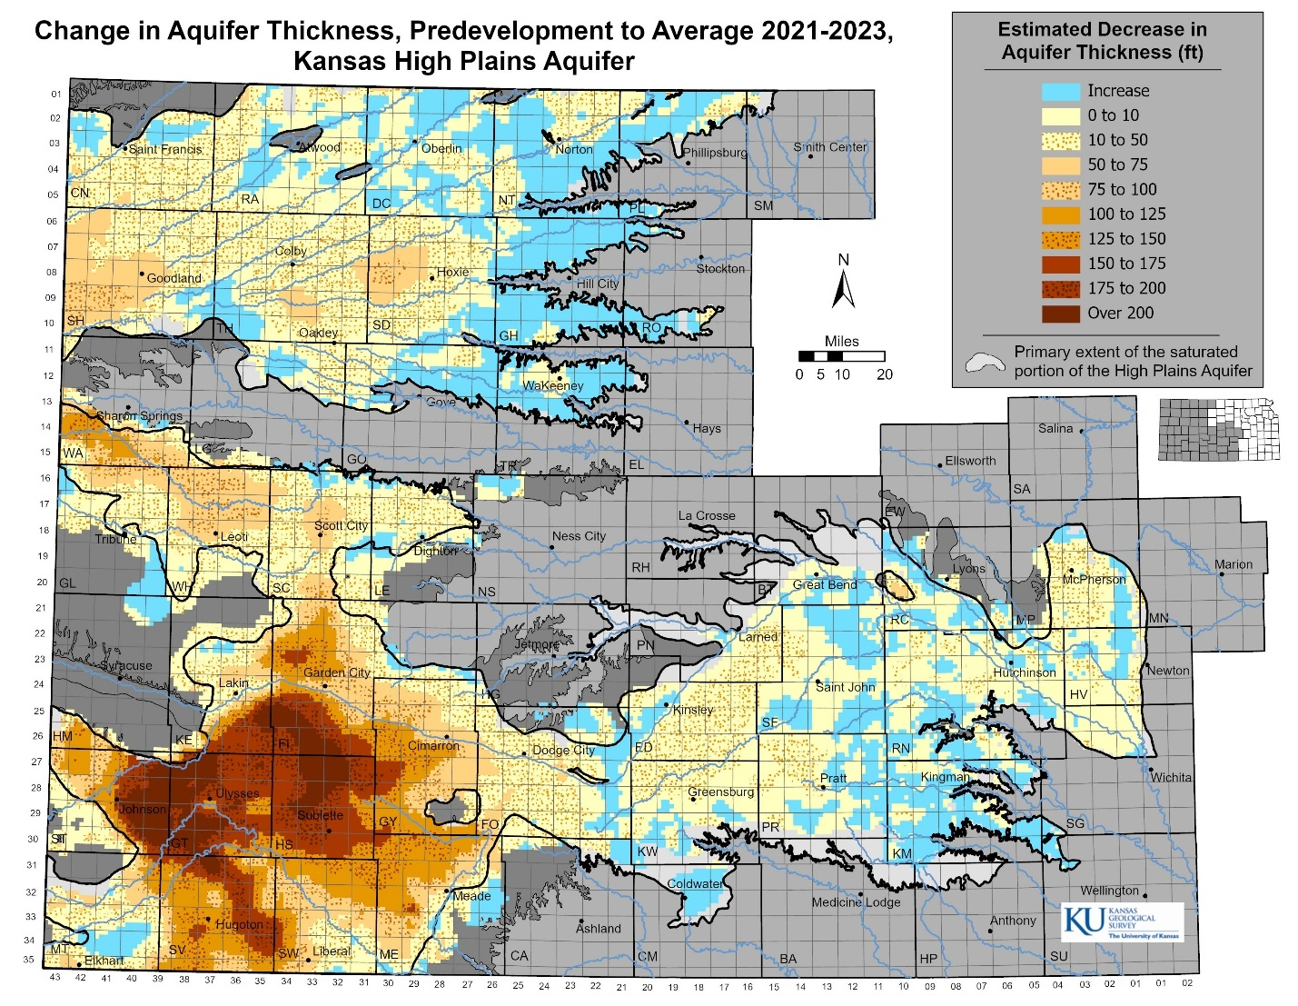

This map looks at the percentage decrease of the aquifers from predevelopment to today.
What color indicates the aquifer thickness is increasing?
What colors indicate the aquifer thickness is decreasing?
Which areas in Kansas have the biggest percentage decrease since development began?
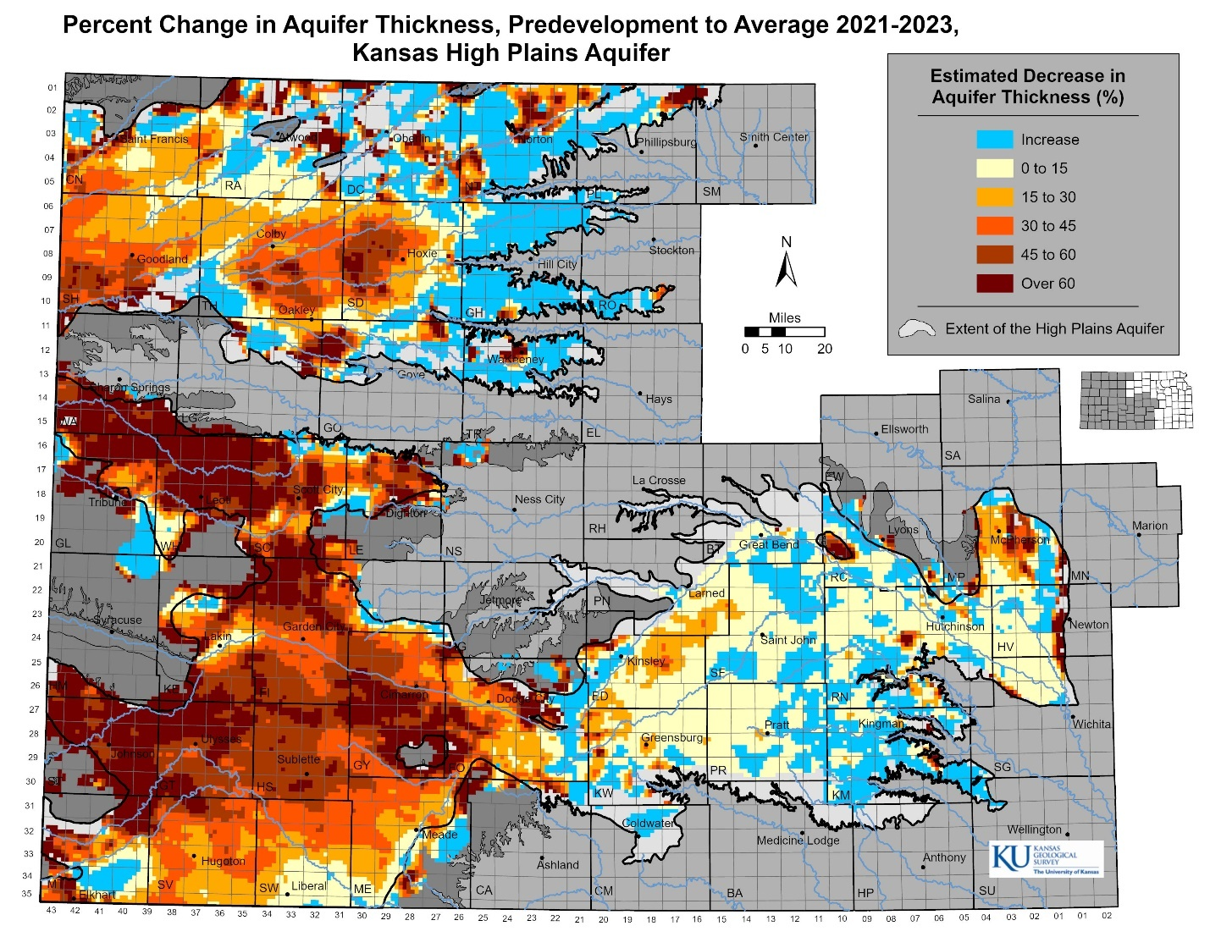

Now let’s look at our final map. We’ll look at pumping sites across Kansas. All the green triangles represent one groundwater pumping well.
Where do we see the most wells? How about the least?
Compare the map to the percentage change map above. What connections can you draw between pumping wells and percentage change of water depth?
