**Historic Earthquakes in Kansas Activity**

Before seismometers were installed, Kansas relied on citizens to report earthquakes to the Geological Survey. This gave us historical data on earthquake locations and strength across the state.

Review these historical accounts of earthquakes in Kansas. Then, use the Modified Mercalli Scale on the following page (using the roman numerals) to determine the strength of these earthquakes at the location they were felt. If you’re not sure, add a question mark after your rating.

*April 24 1867, 2:30 PM*People reported: furniture moving, dishes falling, people falling over, some plaster broke off and fell, people quite frightened and running to the streets, some windows breaking, one chimney reported falling.   
EARTHQUAKE RATING:

*November 8 1875, 5:00 AM*People reported: Nearly everyone waking up, rattling dishes, buildings quiver, doors swinging open.   
EARTHQUAKE RATING:

*May 19 1881, 9:00 AM*People reported: Slight shock felt by several people, sleeping people weren’t awakened.   
EARTHQUAKE RATING:

*November 8 1928, 8:15 AM*People reported: Windows shaking, dishes rattling, objects didn’t fall over.   
EARTHQUAKE RATING:

*December 7 1929, 2:02 AM*People reported: beds shaking, many people waking, windows rattling, no major damage reported.   
EARTHQUAKE RATING:

*August 9, 1931, 1:07 AM*People reported: houses shaking violently, dishes and small items falling and breaking, pictures were thrown off of walls, people fled to streets, furniture overturn, it felt as though beds were lifted and then dropped.   
EARTHQUAKE RATING:

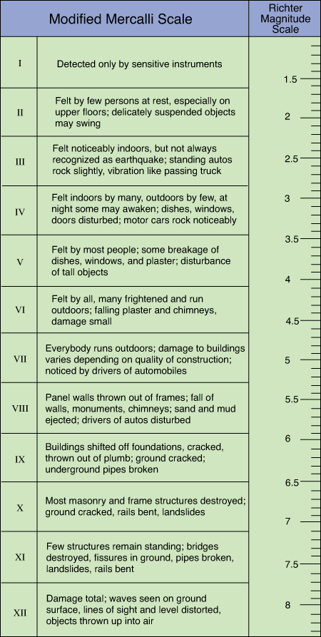

**Activity 2: Isoseismal Lines**

Seismometers are incredibly accurate in determining the earthquake’s epicenter. However, earthquakes have occurred long before the invention and use of these instruments. Traditionally, when we are locating the epicenter, we use eyewitness accounts from various areas affected by the earthquake. Imagine for a moment you throw a rock into a pond, the ripples are strongest at the impact and diminish as they spread out. Likewise, witnesses who report a strong quake are more likely to be closer to the epicenter than those who report a weak one.

This is an earthquake that occurred on January 7, 1906. Determine, as best as you can, what the Modified Mercalli intensity was for each location then write that number on the map provided using the alphabetical labels. Then, connect the largest MM ratings together and move down the scale until all the MM ratings are connected.

|  |  |  |  |
| --- | --- | --- | --- |
| **Locality** | **Map Label** | **Assigned MM Intensity** | **Earthquake Effects** |
| Abilene, KS | A |  | Rattled dishes Movement plainly perceptible Water in glasses showed motion |
| Alma, KS | B |  | Walls rocked, floors weaved Windows rattled, chinaware jumped People felt weak in the knees Low rumbling sound preceded shock |
| Auburn, KS | C |  | Stove lids rattled Houses shook |
| Blue Rapids, KS | D |  | Many people felt trembling or rocking Leaves swayed on house plants Not severe |
| Cleburne, KS | E |  | Some dishes broken Some people very much disturbed, thinking an explosion had occurred |
| Emporia, KS | F |  | Many people frightened, several ran outdoors Dishes rattled, houses shook More severe four mi. north of town, lighter to the east, hardly felt south of Emporia No damage reported |
| Hope, KS | G |  | Buildings trembled Doors slammed shut in houses |
| Junction City, KS | H |  | Panic--people fled to streets Articles shaken from shelves and tables Windows rattled Plaster knocked from walls |
| Kansas City, MO | I |  | Shook chandeliers Rattled dishes Not severe enough to cause alarm |
| Lawrence, KS | J |  | "No doubt about shaking here, although severer to the west" Did not cause alarm |
| Lincoln, NE | K |  | Shook globes and chandelier fastenings distinctly felt although no damage was reported |
| Manhattan, KS | L |  | Walls cracked People rushed from homes in frenzied fear Brick chimneys dislodged from school, depot, houses Dishes thrown together on tables Houses rocked and swayed Shelf contents shaken to floor Persons in the dining room of the Gilett Hotel rushed out into streets Lateral motion followed by vertical movement Aftershock 20 minutes later Vase, lamp or bottle broken in every house Tremor preceded by rumbling sound |
| St. Joseph, MO | M |  | Rattled dishes and tinware Detached pictures from wall Frightened small children No serious damage Tables did freakish stunts, floors swayed, dishes danced Plates on racks attached to wall fell to floor |
| Seneca, KS | N |  | Jarred windows Rattled dishes |
| Topeka, KS | O |  | Roaring sound followed by the shock Shook houses, windows, doors, dishes Glass lamps shaken Man awakened China thrown from pantry shelves Baby fell from lounge Slight shock resulting in curious inquiries at telephone office People filled the streets |
| Wamego, KS | P |  | Plaster shaken from ceilings Things tumbled about generally Pictures shaken from walls Bottles shaken from shelves "The amount of damage will be considerable" |
| Westmoreland, KS | Q |  | Plastering jarred off courthouse in places |
| White Cloud, KS | R |  | Felt, but "not very severe" |
| Wichita, KS | S |  | Slight shock felt |
| Woodbine, KS | T |  | Dishes rattled in cupboards |

Map of reported earthquake incidents on January 7, 1906

What was the largest reported Modified Mercalli number for the earthquake?

Where is the epicenter of the earthquake?

What trends do you notice for earthquake’s strength across the region?

**Activity 3: Historical vs Measured Earthquakes in Kansas**

Below is a list of historical earthquakes in Kansas from 1867 to 1961. After 1961, earthquakes were reported by seismometers.

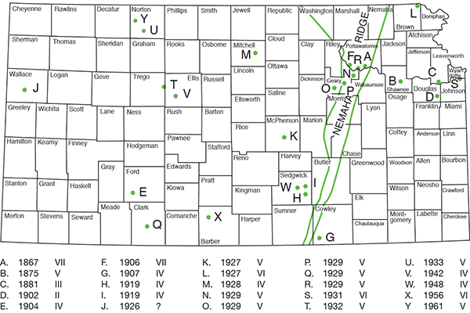

In the course of 94 years, how many earthquakes were reported?

How many of them were I? II? III? IV? V?  
VI? VII? VIII?

What do you notice? Why do you think some earthquakes are more reported than others?

Historically, a majority of the population of the state lives in the northeastern section and we have a big population in Sedwick county where Wichita is located. In western Kansas, the population is more rural and spread out. Based on this information, what kind of bias do we see when people report earthquakes?

Let’s now look at a map of earthquakes in Kansas recorded by KGS seismometers from 1977 to 1989. The chart represents number and strength of earthquakes recorded during this 12 year timespan.

In the course of 12 years, how many earthquakes were recorded?  
What was the average number of earthquakes reported per year?

Circle hotspots on the map where earthquake occurrence is more frequent.

What do you notice about this map compared to earthquakes reported by people? Why do you think it’s different?