**Activity 1: Time Difference Between Two Moving Objects**

Seismologists use seismometers to identify the location of an earthquake. When an earthquake occurs at the epicenter, the force spreads out like ripples in a pond. An earthquake produces Primary and Secondary Waves, also known as P-waves and S-waves. P-waves move faster than S-waves. As we move farther and farther away from the epicenter, the time difference between the two waves become larger and larger. We use the wave speeds and their time difference to pinpoint the epicenter of the earthquake.

To demonstrate the time difference, let’s first look at two cars going at two different speeds.

Car A is travelling at 30 kilometers per hour while Car B is travelling at 60 kilometers per hour.

At Hour 1, how far has Car A travelled? ______________ How about Car B? __________

What’s the total distance between the two cars at Hour 1?

At Hour 2, how far has Car A travelled? _____________ How about Car B? ___________

What’s the total distance between the two cars at Hour 2?

How has the distance between the two cars changed over time?

Now let’s change it up. How long will it take in hours for both cars to reach 300 kilometers? You can determine this by using the formula X hours=Kilometers/Kilometers per Hour

Car A will take ____ hours to reach 300 kilometers. Car B will take ____ hours to reach 300 kilometers.

Okay let’s take this one step further. Let’s say you’re on a road and you have a timer on hand. You start the timer when Car B passes by you and end it when Car A passes by you. You noticed there’s a 4 hour time difference between the two cars. Assuming they were travelling the same speeds, let’s figure out how far away their starting point was.

As both Car A and Car B travelled the same distance we can write the formula as follow

(60 kilometers per hour)(Time)=(30 kilometers per hour)(Time+4 hours) or (60kph)(T)=(30kph)(T+4 hours)

(60kph)(T)=30kph(T)+120 km, 30kph(T)=120 km, T=4 hours

Now that we know that Car B has travelled 4 hours since it began, we can calculate how far it was from its starting point using distance=speed X time. **In this case d=(4 hours)(60 km per hour) which equals 240 km. The cars have travelled 240 kilometers since they began.**

Now try it yourself but this time, the time difference is 6 hours. Calculate how far the two cars have travelled since they began.

**Activity 2: P and S-Waves**

Let’s now look at some seismograph charts and identify what P-waves and S-waves look like. In general, P-waves will create a minor disruption on the chart whereas S-waves will create a major disruption. Seismologists determine when the P and S-waves arrive based on these disruptions.

Here’s an example of one courtesy of USGS

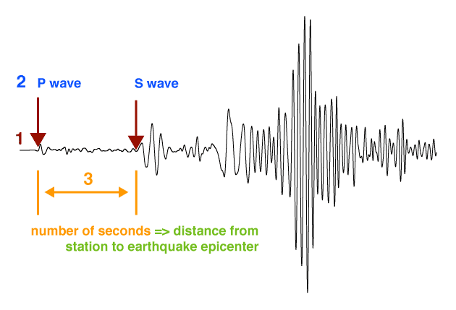

Now let’s look at an earthquake that occurred on February 11, 2023. This seismograph shows three stations located in Kansas, each reading a signal at different times. Circle when you think the P and S-waves started for each station.

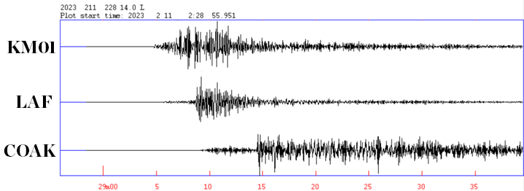

Here are the P and S-wave arrival times for each station. Calculate the time difference for each station’s P and S-wave.

KM01: P-wave: 29 min and 4.7 sec, S-wave: 29 min and 7.1 sec, DIFFERENCE:

LAF: P-wave: 29 min and 5.6 sec, S-wave: 29 min and 8.7 sec, DIFFERENCE:

COAK: P-wave: 29 min and 9.1 sec, S-wave: 29 min and 14.5 sec, DIFFERENCE:

Based on the time difference, which station is the closest to the epicenter? How about the farthest?

**Activity 3: Locating an earthquake**

Seismologists can use the time difference between the P and S-wave on a seismograph to determine how far away the epicenter is from the seismometer. Seismologists need to have three seismometers to pinpoint its location. By drawing a geographic circle around each station, with the radius being the distance we calculated, we can observe where the circles intersect to determine the epicenter. In a perfect world, the circles would look like this (left figure)

However, as data can get fuzzy due to interference, more often the graphs can look like this (right figure). Regardless, we can still get a pretty good idea where the epicenter is based on this near overlap.

Let’s try examples using some basic seismograph maps. Circle where the epicenter is based on these six maps.

**Activity 4: The February 11, 2023 Earthquake**

A 3.1 earthquake was picked up by three seismometers, KM01, LAF, and COAK, in southern Kansas. Let’s locate the earthquake based on the previous information and skills that we have used.

First, write down the time difference between the P and S-waves for each station as calculated in Activity 2

KM01: LAF: COAK:

Next, we’ll be using these P and S-wave speeds to determine the epicenter location

P-wave: 7.3 km/second, S-wave: 3.7 km/second

We know that Speed X Time = Distance. We also know that the distance travelled for both the P and S-waves is the same. Finally, we know that the P and S-waves started the same time but that the S-waves took longer to reach the station. So we can write out the equation like this

(P-wave Speed)(Time)=(S-wave Speed)(Time+Time Difference) or for KM01

(7.3 km/second)(Time)=(3.7 km/second)(Time+2.4 seconds) we can then do algebra and rewrite it as 7.3T=3.7T+8.88, then 3.6T=8.88, and finally T=2.5 seconds

To calculate the distance, we go back to Distance=Speed X Time, to apply it for P-waves

Distance=(7.3 km/second)(2.5 seconds)=18.25 km

**As such, the distance between station KM01 to the epicenter is 18.25 km.**  Now do this for the other two stations

Write down the distance from the epicenter to the other two stations here

LAF:

COAK:

Wellington

Kingman

Wichita

Measure the distance of the earthquake from each station (blue triangles) using a ruler. One centimeter equals 10 km. So if the distance was 15 km the ruler length would be 1.5 cm. If the distance was 71 km then the ruler length would be 7.1 cm. After you pinpoint your distance, draw a circle around the station. After you draw each circle, determine where the circles are closest together to determine the epicenter’s location.